**Hover Effect:**  
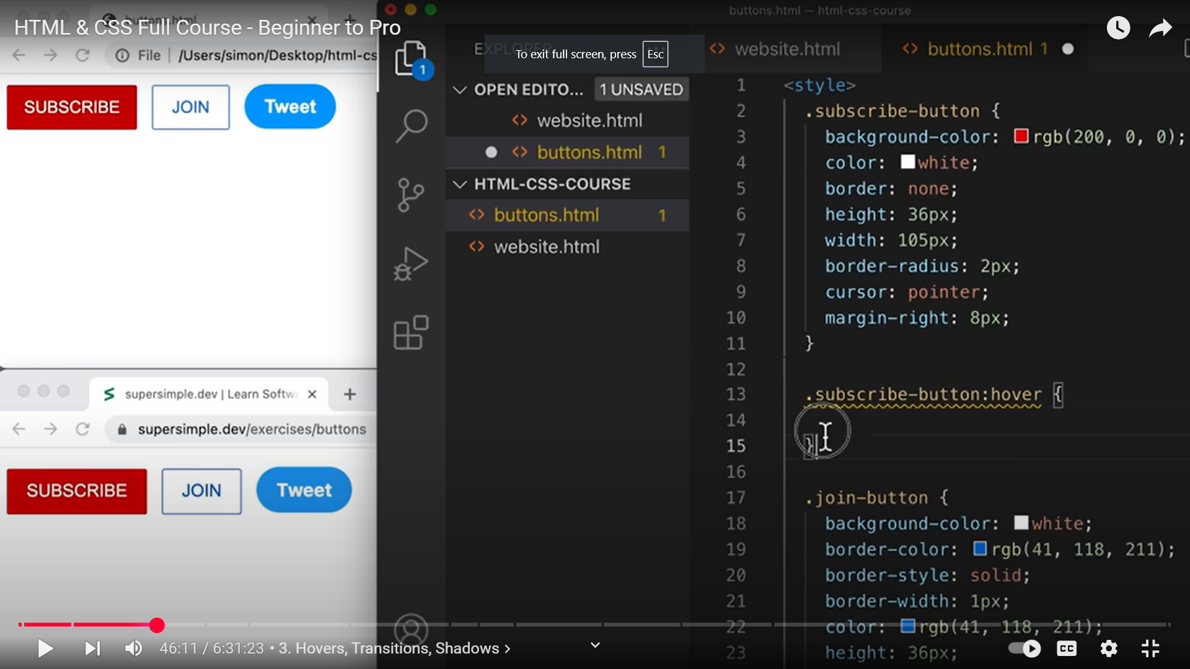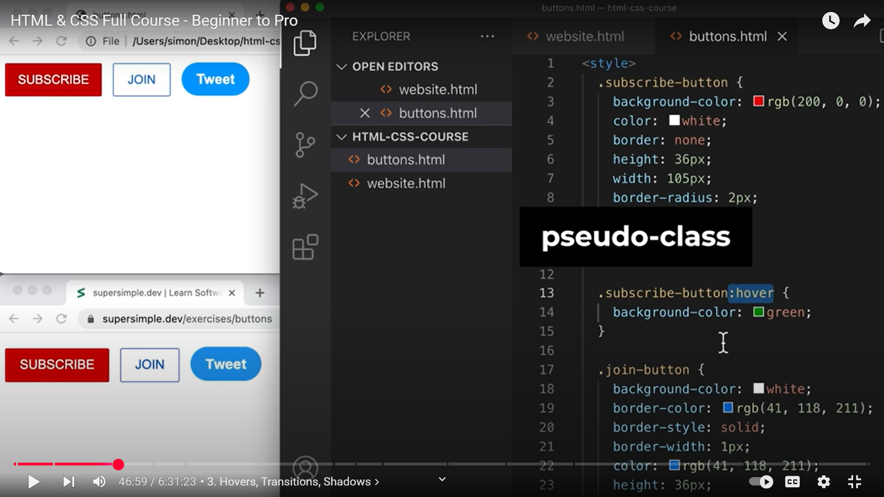 **AT 13, PSEUDO CLASS!!!!!!!!!!!!!!!!!!!!!!!!!!!!!!!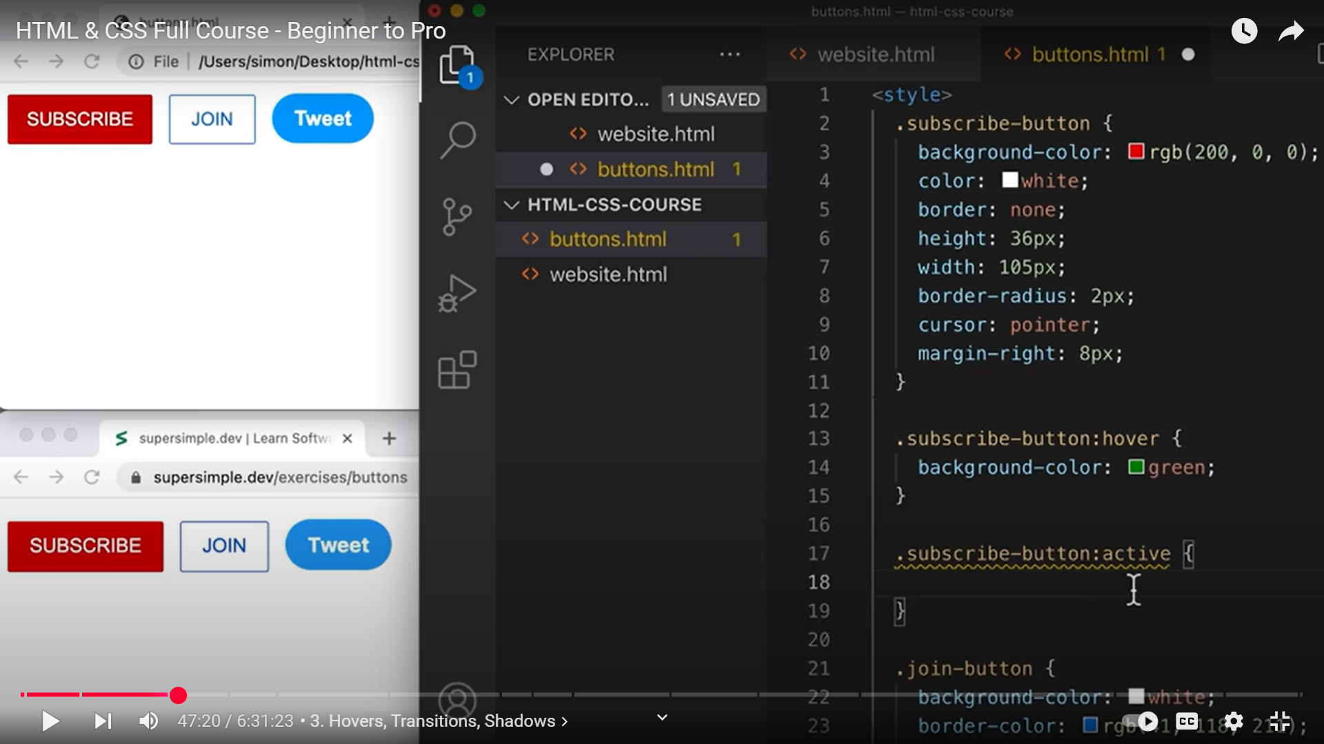 AT 17, ANOTHER PSEUDO CLASS.**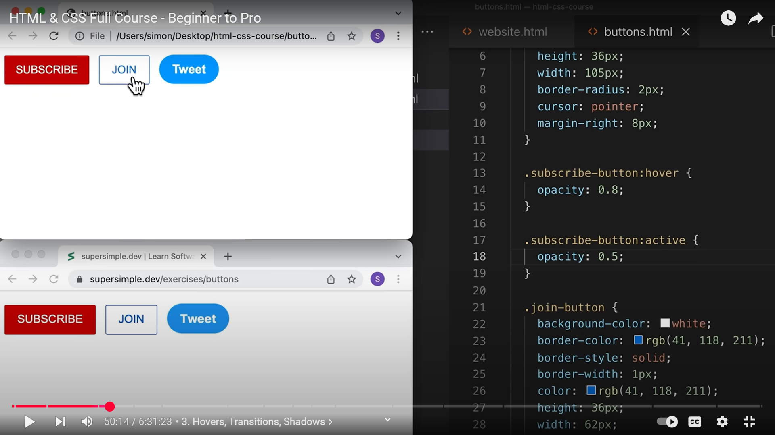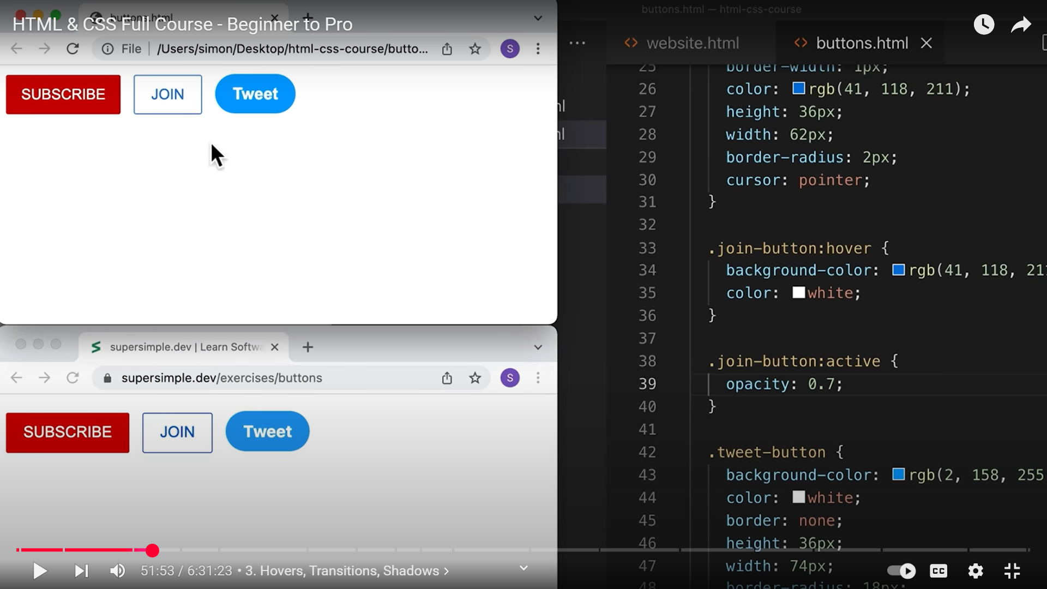

**TRANSITIONS: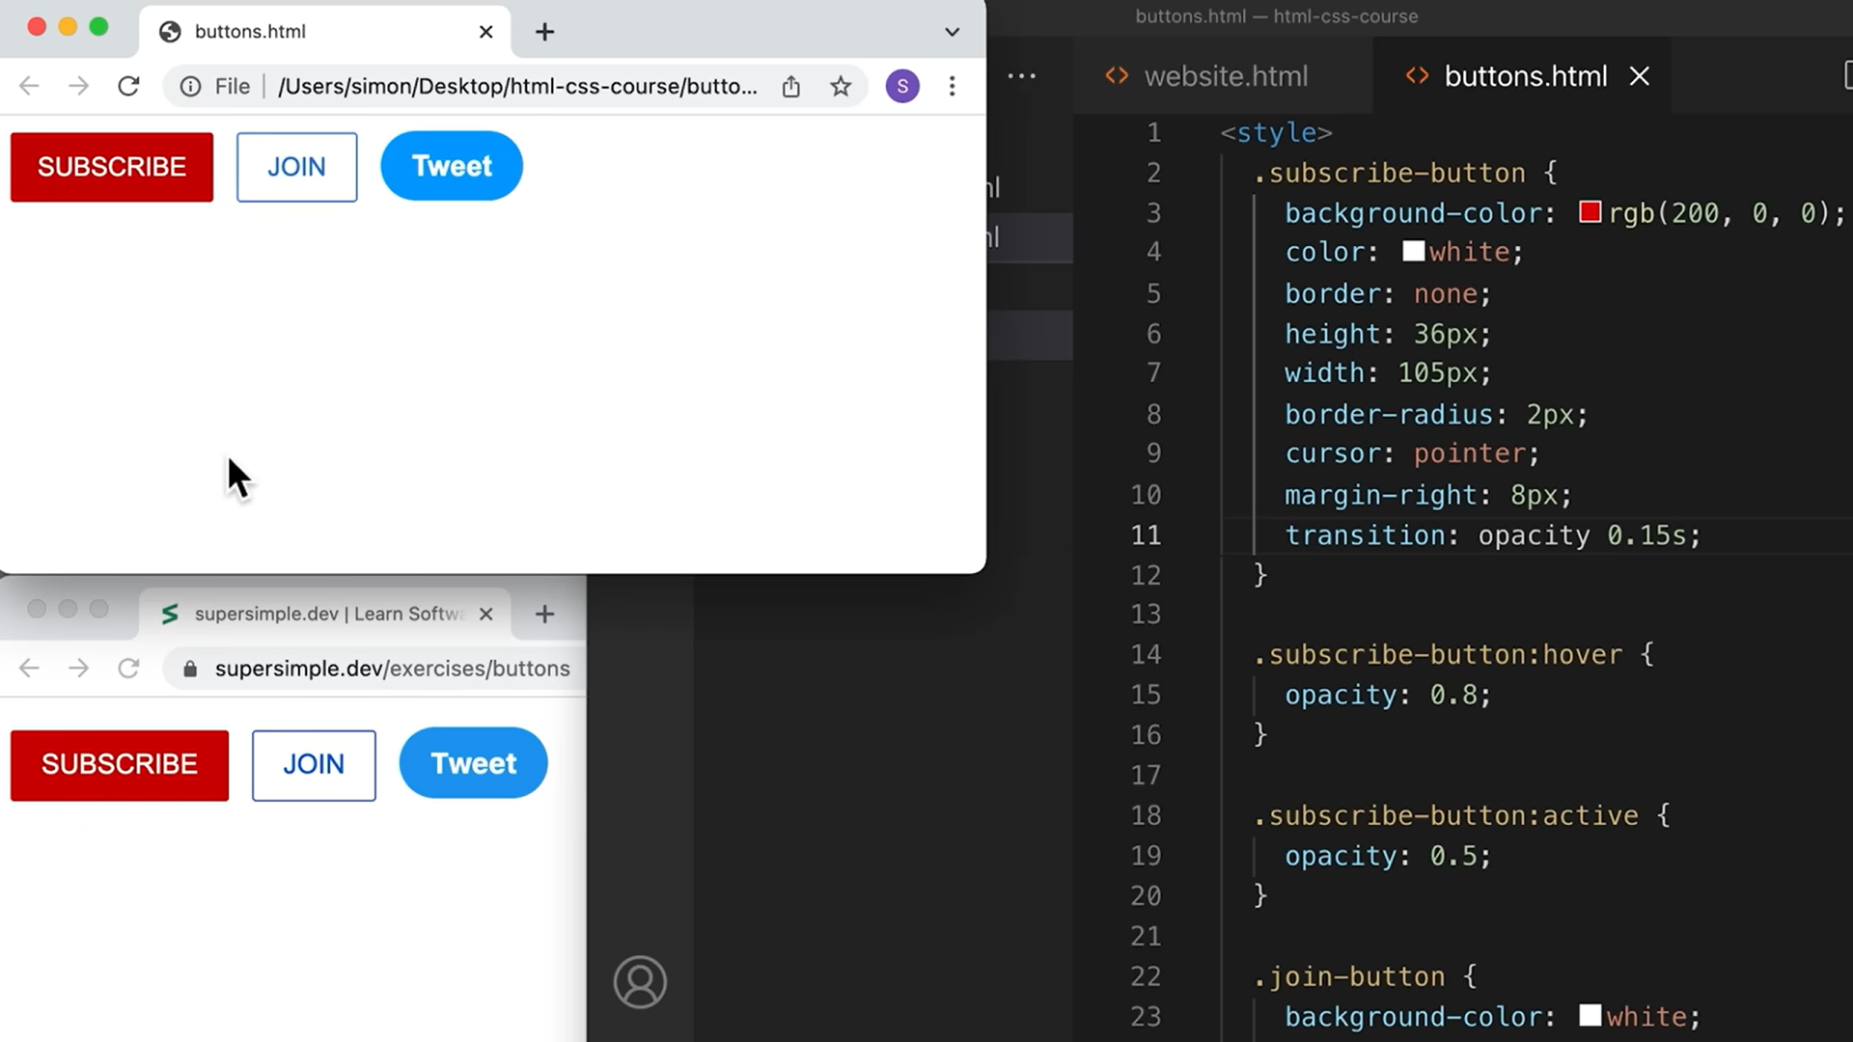 11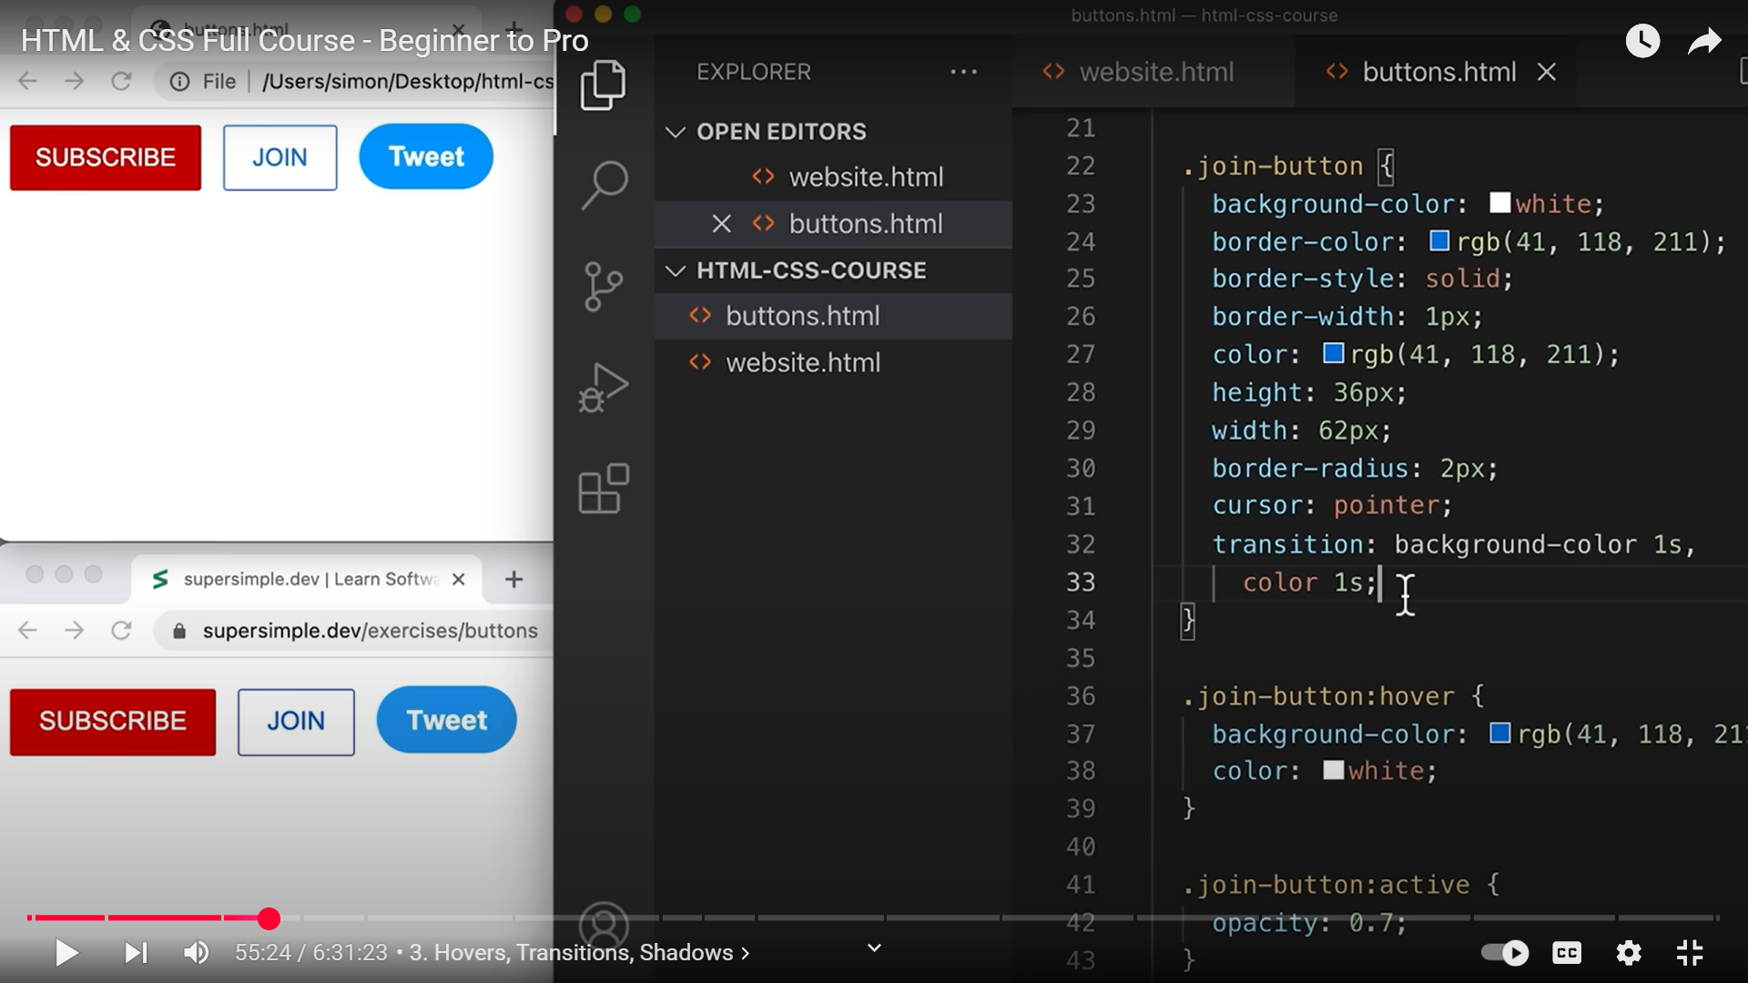 32,33 ---- > MULTIPLE PROPERTIES CAN BE TRANSITIONED!!!!!!!!!!!!!!!!!**

**TRANSITION PROPERTIES SHOULD NOT BE PLACED IN HOVER CLASS !!!!!!!!!!!!!!!!!!!!**

**SHADOWS: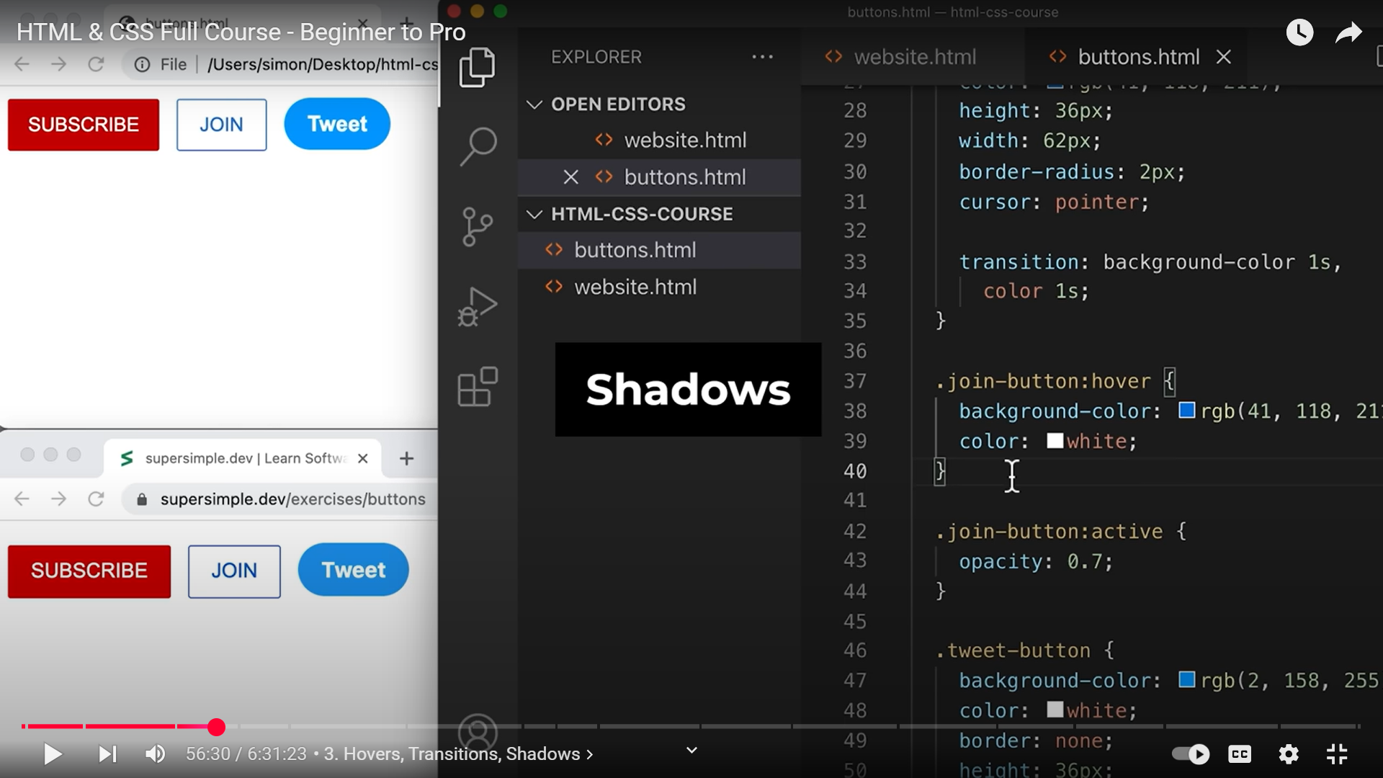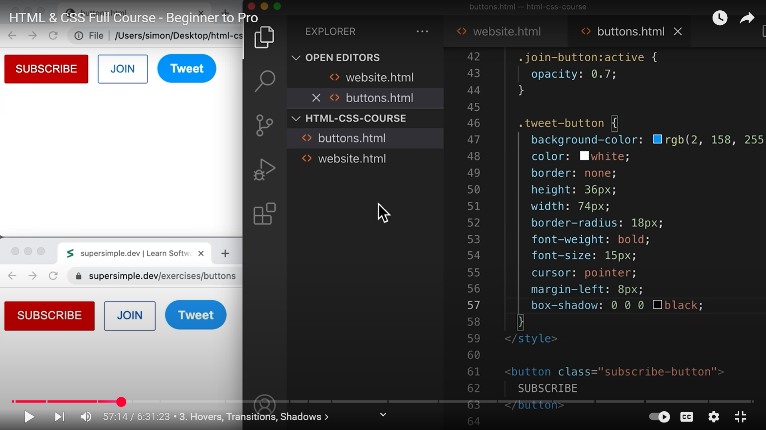 box-shadow IS THE CSS PROPERTY FOR CHANGING THE SHADOW STYLES. IT TAKES 4 VALUES!!!!!!!!!**

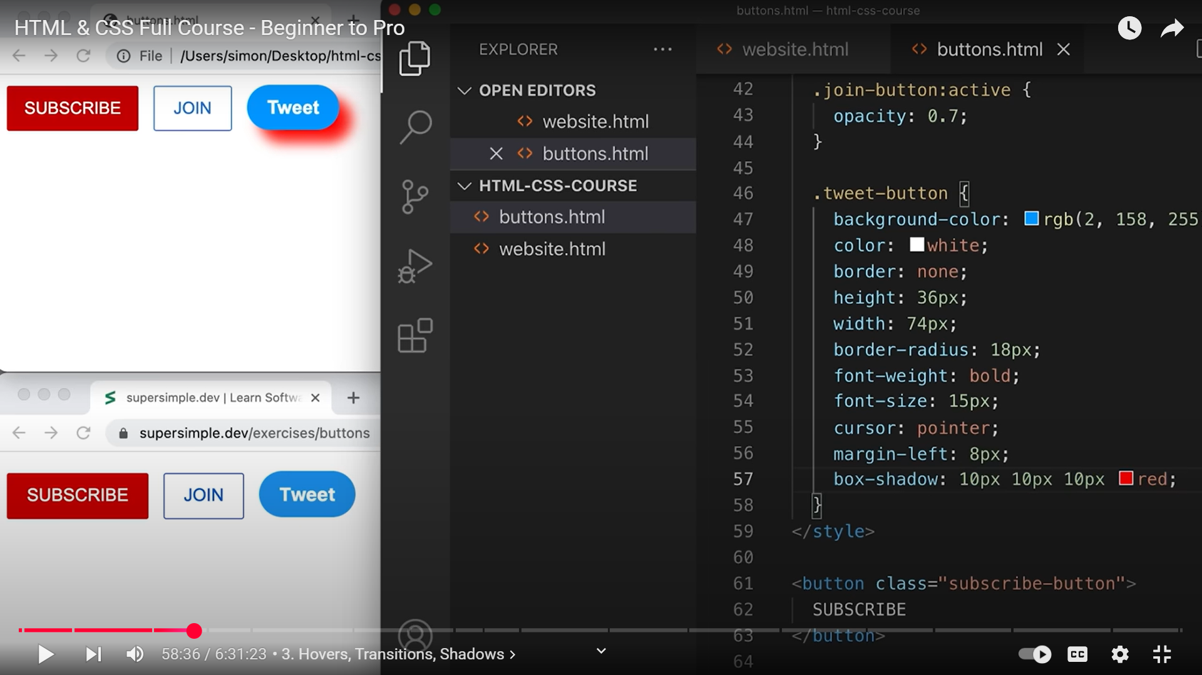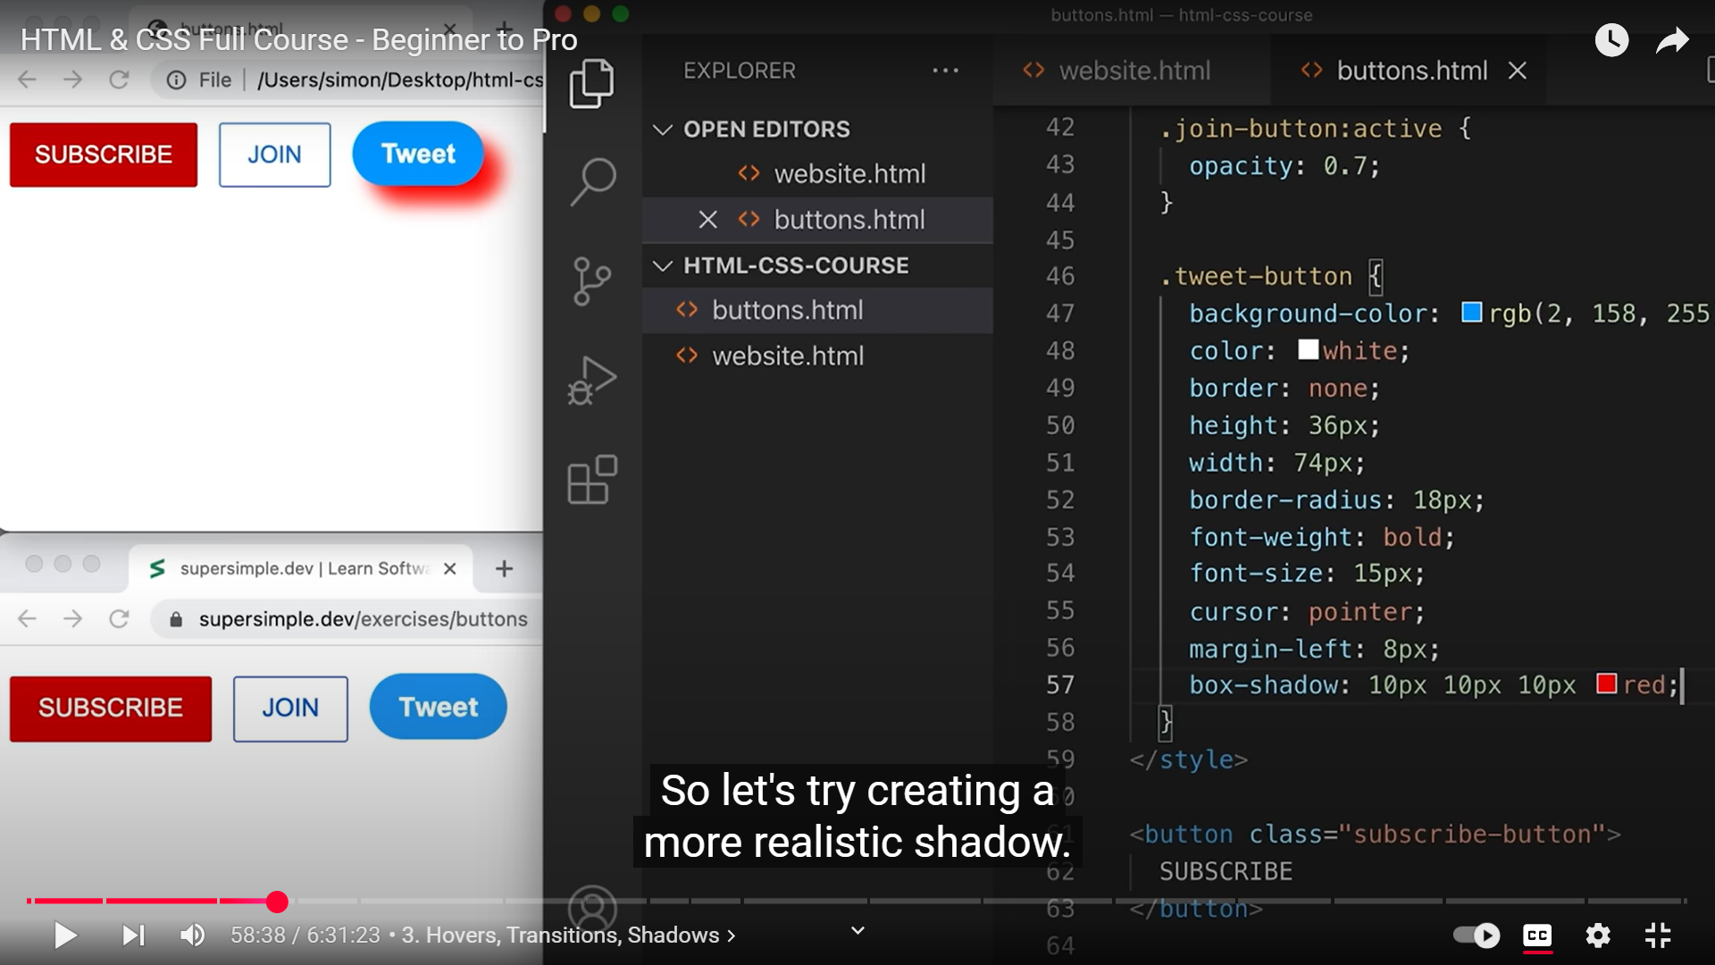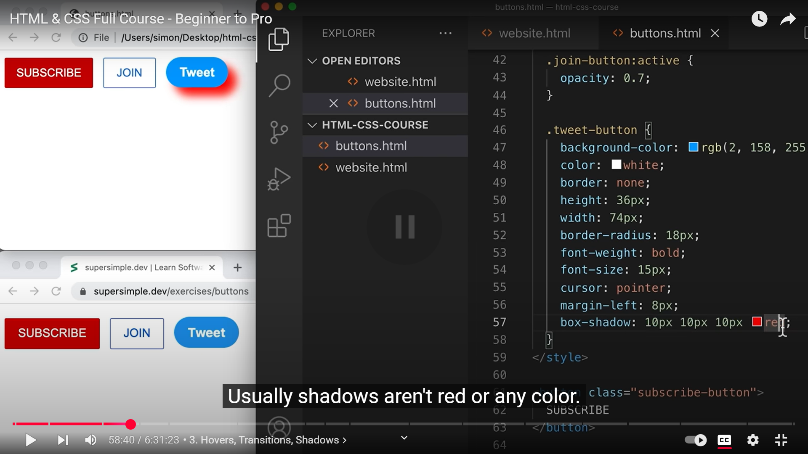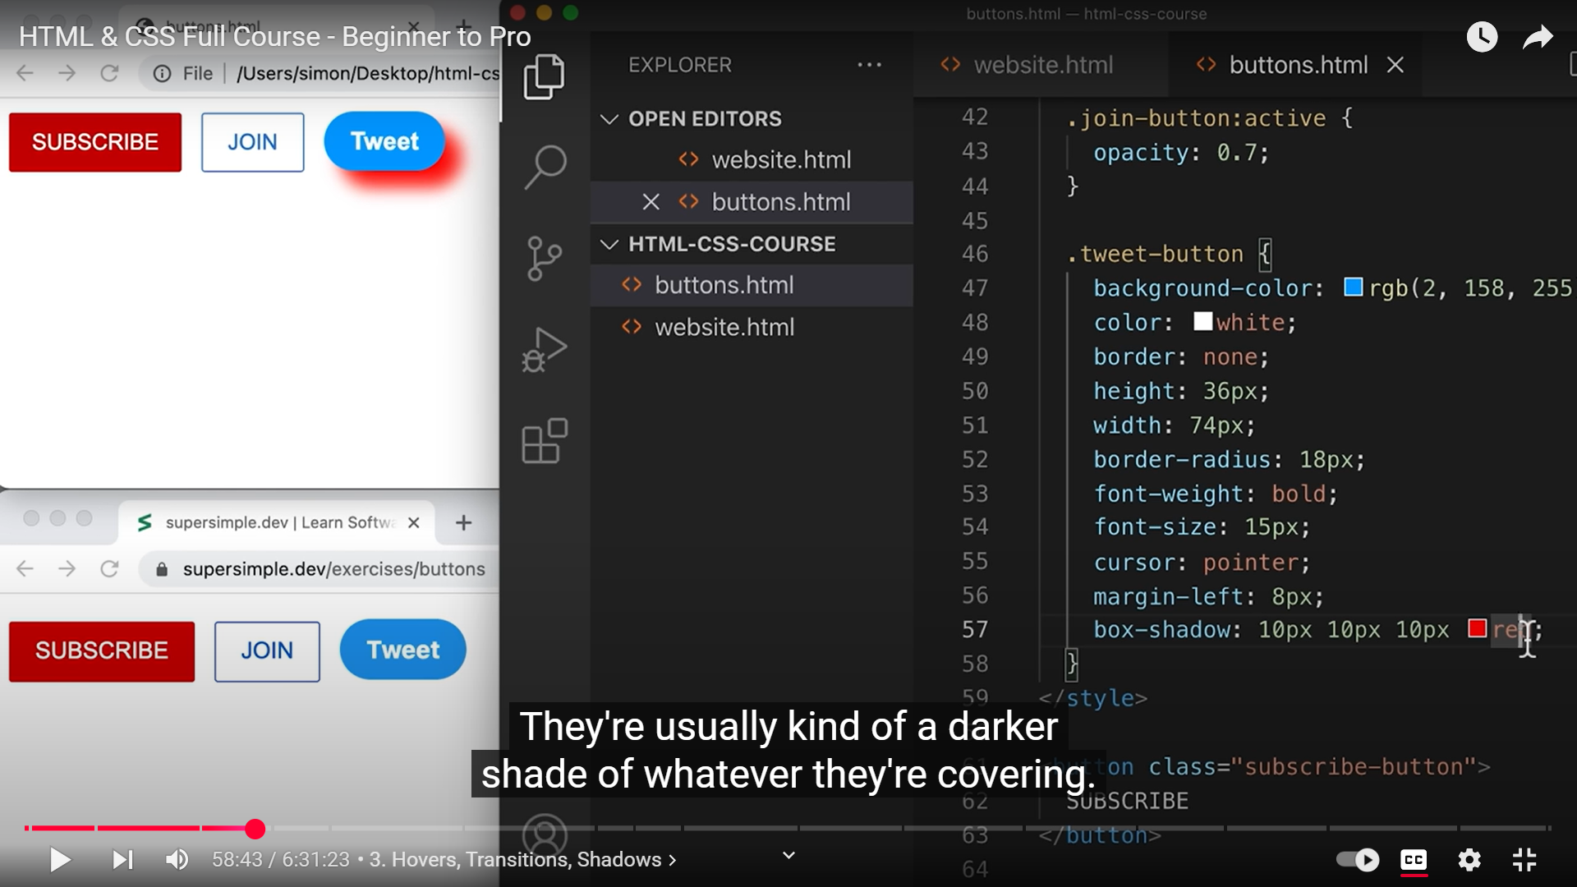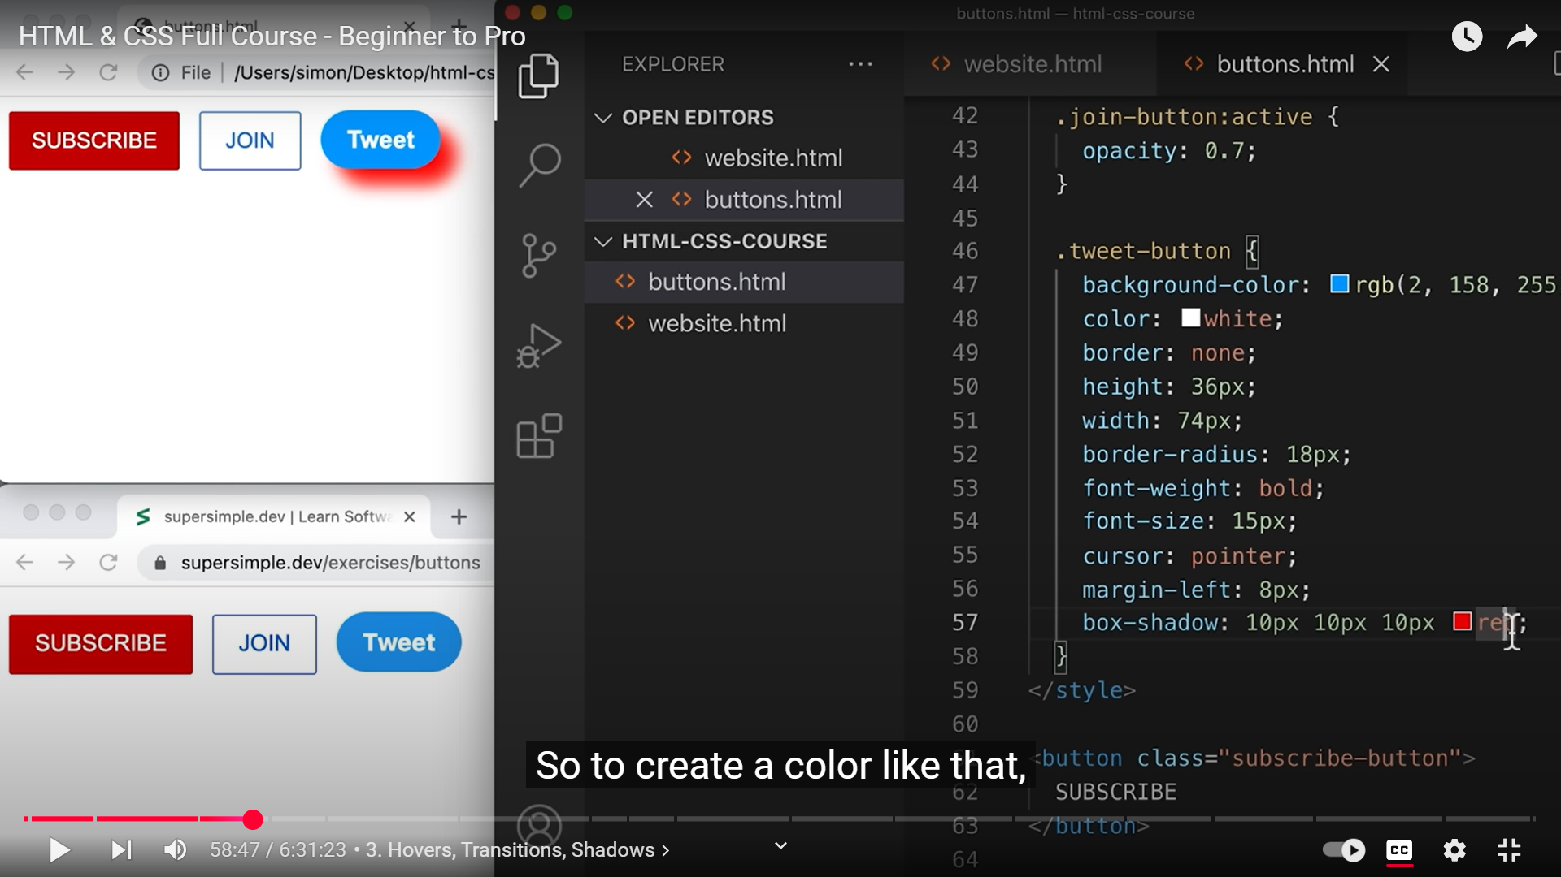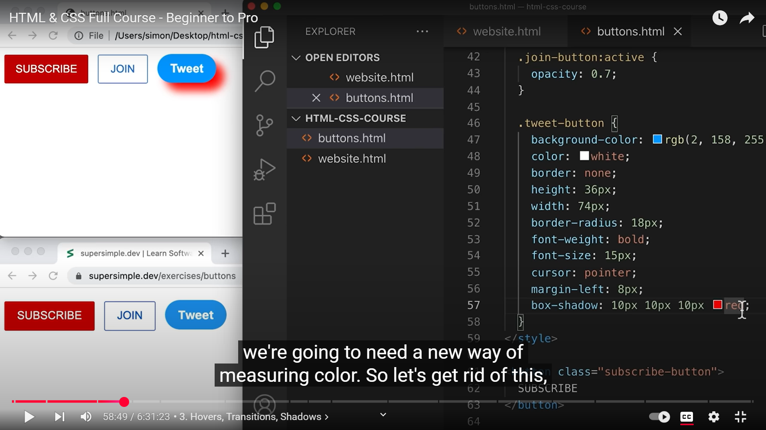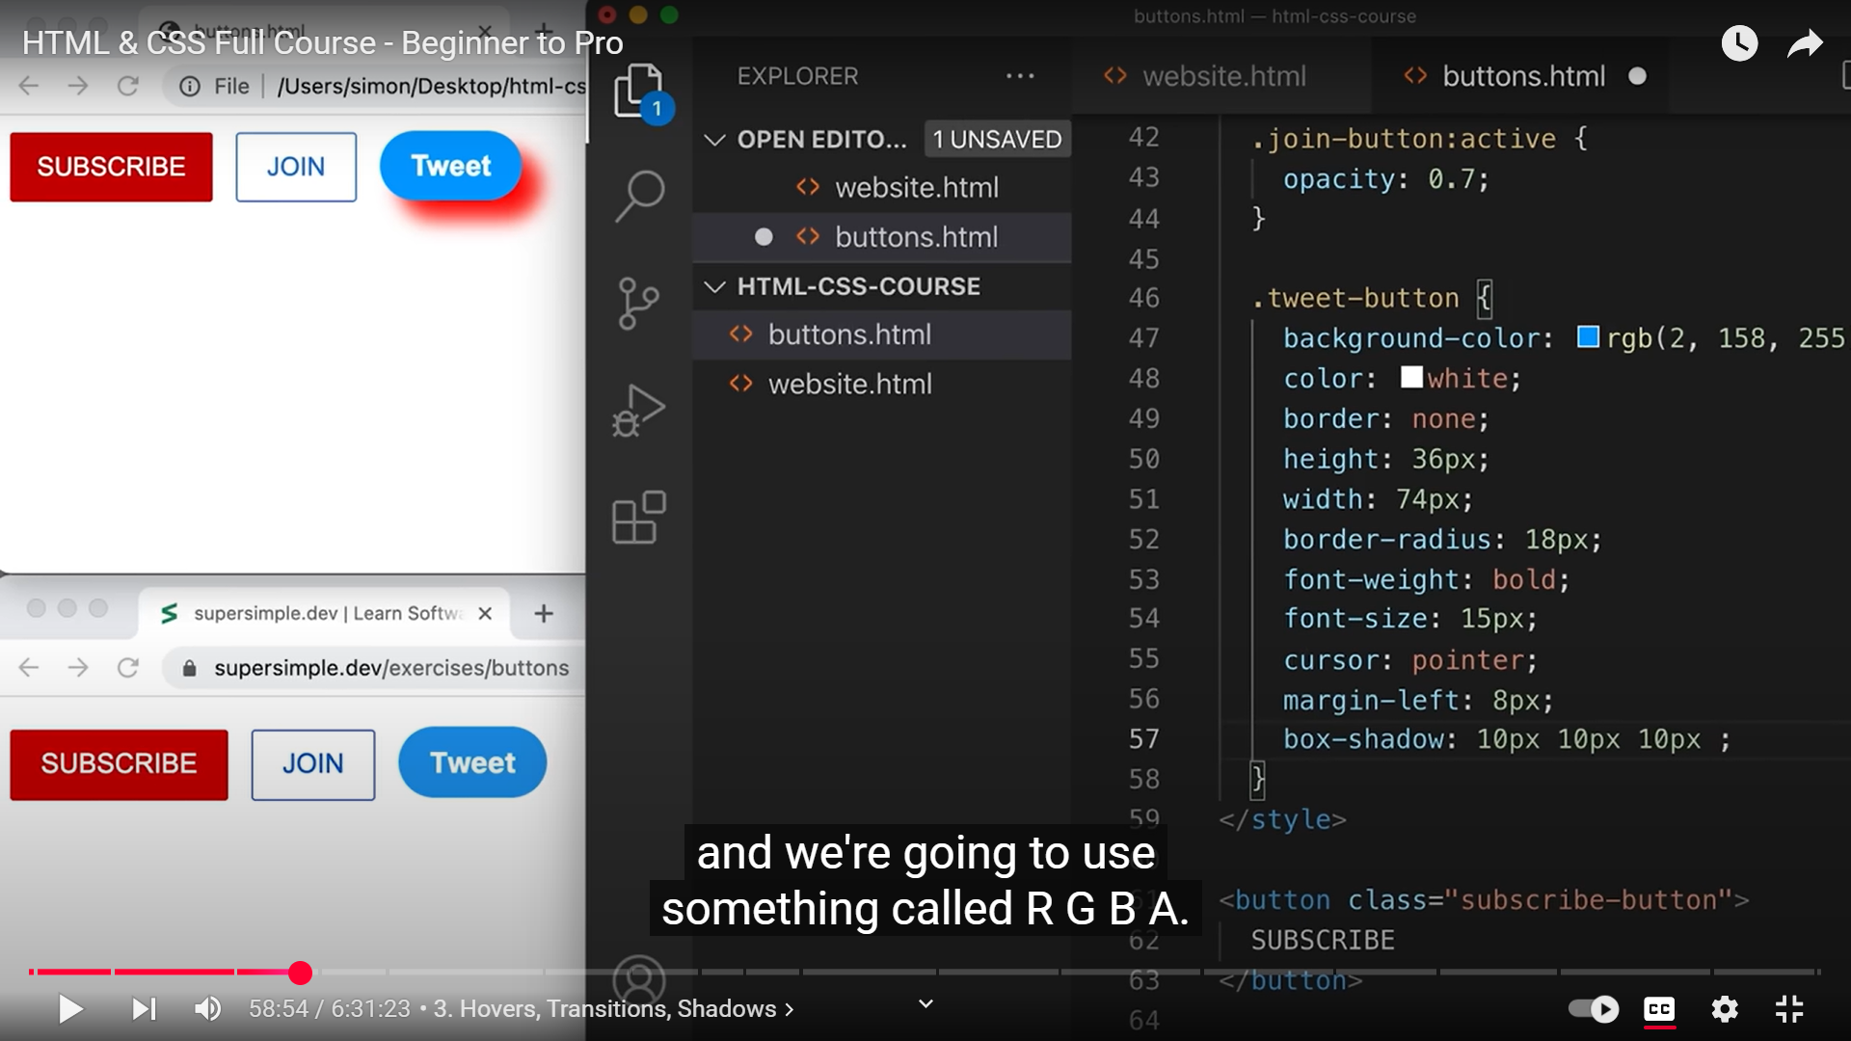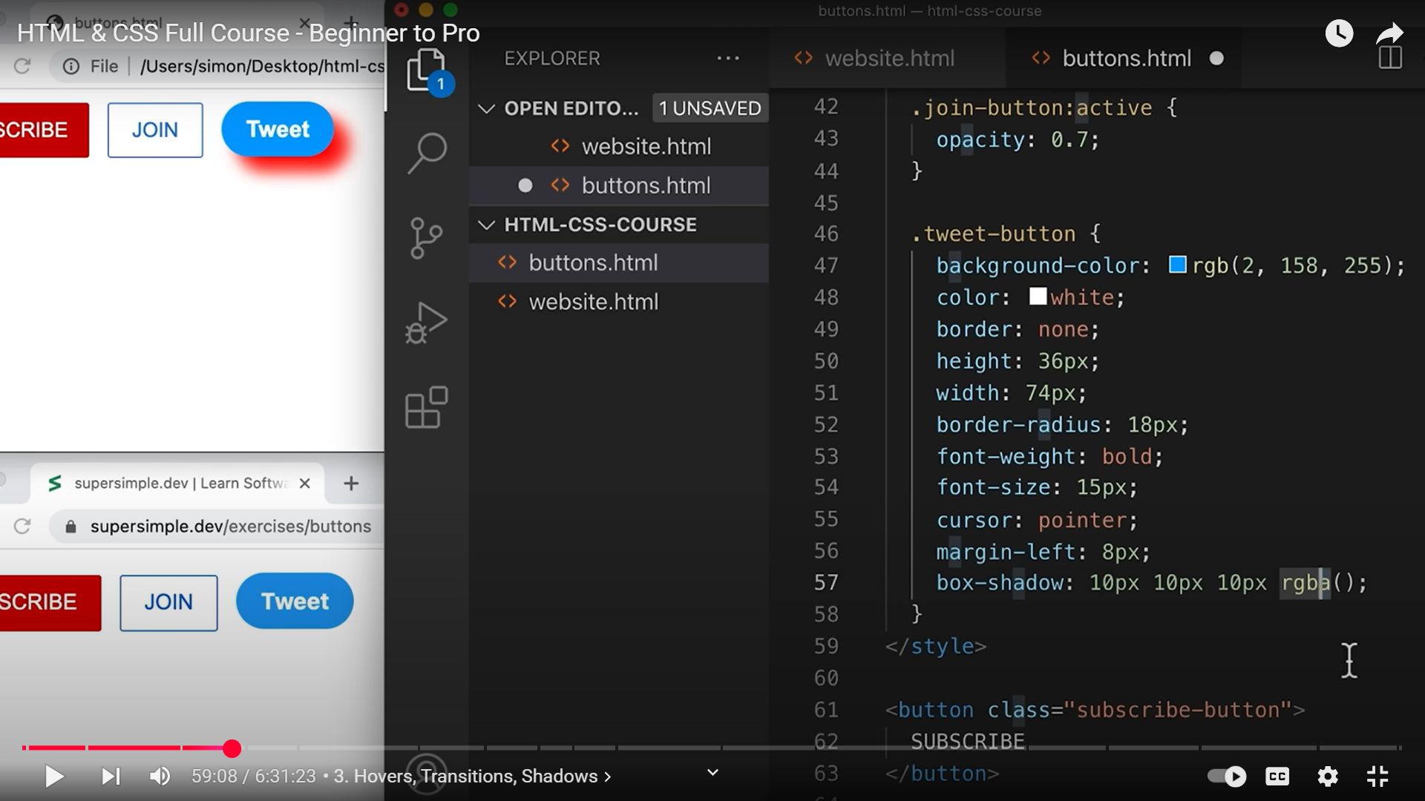 **57, rgba(), a MEANS OPACITY**

